

**MATHEMATICS  
METHODS**

**Test 5 –Differentiation and Applications of Differentiation  
Chapters 2 and 3 Sadler**

**Semester 2 2015**

**Section Two – Calculator Assumed**

Time allowed for this section

Working time for this section: 35 minutes

Marks available: 27 marks

**Materials required/recommended for this section**

***To be provided by the supervisor***This Question/Answer Booklet  
Formula Sheet

***To be provided by the student***

Standard items: pens, pencils, pencil sharpener, eraser, correction fluid/tape, ruler, highlighters

Special items: drawing instruments, templates, notes on one unfolded sheet of A4 paper, and up to three calculators satisfying the conditions set by the Curriculum Council for this examination.

**Important note to candidates**

No other items may be used in this section of the paper. It is **your** responsibility to ensure that you do not have any unauthorised notes or other items of a non-personal nature in the room. If you have any unauthorised material with you, hand it to the supervisor **before** reading any further. All working out **must** be shown for full marks to be awarded.

1. (9 marks)
2. On the axes below, sketch the graph of y = x3 – 5x2 + 2x – 3 [3]

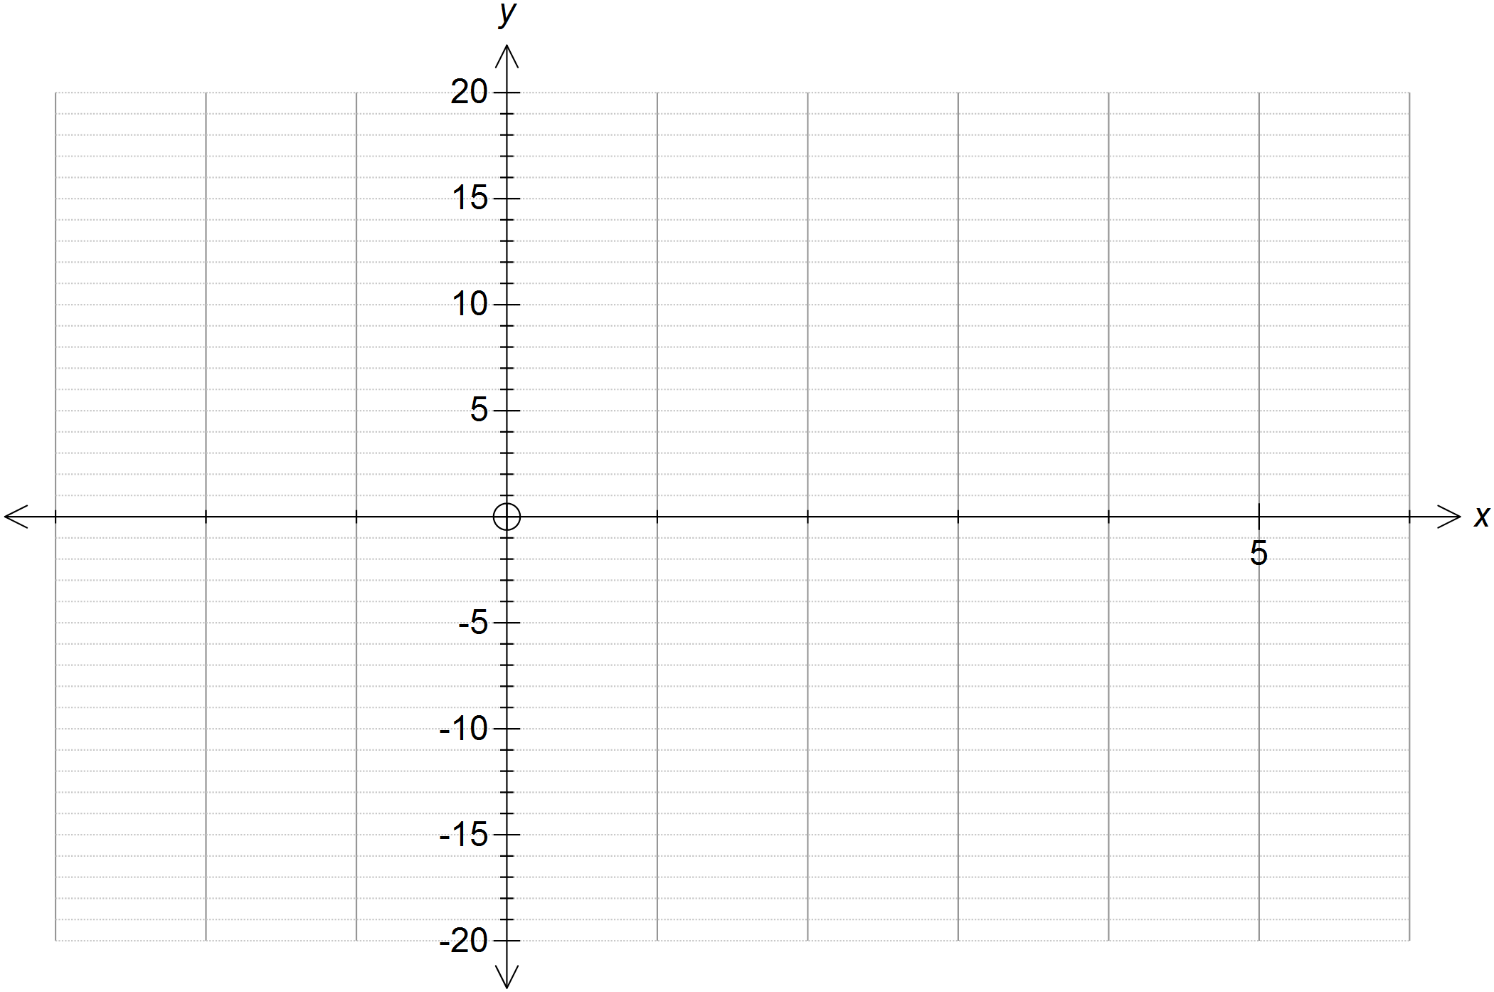

1. Show all of the x-intercepts and y-intercepts on the graph above. [2]
2. Find  [1]
3. For what values of x does the tangent to y = x3 – 5x2 + 2x – 3 have a negative slope? [1]

1. Sketch the tangents to the curve, y = x3 – 5x2 + 2x – 3, at the points where x = -1 and

x = 4. [2]

1. (8 marks)  
   A window consists of a rectangle and a semi-circle as shown. The amount of light passing through this window is directly proportional to the area of the window.
2. If the perimeter of this window is 10m, show that y, the length of the rectangular part of the window, is given by



 [2]

1. Show that the area of the window in terms of *x*, A(*x*) is given by [3]

$A\left(x\right)=5x-\frac{x^{2}}{2}-\frac{πx^{2}}{8}$.

1. Use differentiation to find the value of *x*, to the nearest *cm*, that allows the maximum amount of light through the window. [2]
2. Calculate the maximum area enclosed by this frame to the nearest *cm2*. [1]

1. (5 marks)

The engineers managing the crude–oil extraction of an oil well predicted in 1974 that the remaining amount of oil, *P* (in thousands of barrels), over time, *t* (in years after 1974), is given by the expression:

*P* = *t*3 – 110*t*2 – 200*t* + 210 000

1. What quantity of crude–oil was in the well in 1974? [1]
2. What quantity of crude–oil will be left in the well in 2015? [1]
3. According to their prediction, during which year will the well become empty? [1]
4. Find a rule for the rate of decrease of *P* in thousands of barrels per year. [1]
5. Calculate the rate at which *P* will be decreasing in barrels per year in 2020. [1]
6. (5 marks)  
   The capacity (volume) of a sealed cylindrical can is 375ml (375cm3).
   1. If the volume of the can is given by , show that the height of the can is given by  [1]
   2. The rule for the surface area of a cylinder is. Calculate the base radius and height of the can which will give the minimum surface area of the can. (Hint: use your calculator to find the minimum.) [2]

**End of Test**